Affordable & Competent Courses | iNeuron.ai

**E-Commerce Dashboard**

**Low Level Design (LLD)**

**Nikki Mittal**

Affordable & Competent Courses | iNeuron.ai

**DOCUMENT VERSION CONTROL**

|  |  |  |  |
| --- | --- | --- | --- |
| **Date Issued** | **Version** | **Description** | **Author** |
| **11th January, 2023** | 1.0 | First Version of Complete LLD | Nikki Mittal |
|  |  |  |  |

Affordable & Competent Courses | iNeuron.ai

**CONTENTS**

1. Introduction……………………………………………….4
   1. What is Low-Level Design Document?.......................4
   2. Scope…………………………………………………4
2. Architecture………………………………….…...............5
3. Description……………………………………………..5-8
   1. Problem Statement……………………………………5
   2. Data Collection……………………………………….5
   3. Data Description…………………………………...…6
   4. Data Transformation………………………………….7
   5. Deployment…………………………………………...7
   6. Insights……………………………………………..7-8
4. Unit Test Cases……………………………………………8

Affordable & Competent Courses | iNeuron.ai

1. **Introduction**
   1. **What is Low-Level Design Document?**

The Low-Level Design Document (LLD), also known as an LLDD, aims to provide the core logic design of the actual computer code for the dashboard. Class diagrams with methods and relationships between classes and programme specifications are described using LDD. In order for the programmer to create the programme directly from the document, it describes the modules.

* 1. **Scope**

Low-Level Design is a component level design process that uses a sequential process of refinement. Data structures, necessary software architecture, source code and finally performance algorithms can all be designed using this method. Overall, during requirement analysis, the data organization may be created and then refined during data design work.

Affordable & Competent Courses | iNeuron.ai

1. **Architecture**

**Source: https://towardsdatascience.com/fundamentals-of-data-architecture-to-help-data-scientists-understand-architectural-diagrams-better-7bd26de41c66**

1. **Description**
   1. **Problem Statement**

An online e-commerce company's analytics team wants to create a sales dashboard to evaluate sales based on different product categories. The business aims to provide people more choice over product categories so they may choose one and can observe the trend month- and product-wise as appropriate.

* 1. **Data Collection**

The dataset of the e-commerce company is provided in the form of Excel workbook.

Affordable & Competent Courses | iNeuron.ai

* 1. **Data Description**

The dataset contains the following columns:

* Order ID
* Order Date
* Ship Date
* Aging
* Ship Mode
* Product Category
* Product
* Sales
* Quantity
* Discount
* Profit
* Shipping Cost
* Order Priority
* Customer ID
* Customer Name
* Segment
* City
* State
* Country
* Region
* Months

Affordable & Competent Courses | iNeuron.ai

* 1. **Data Transformation**

The dataset doesn’t have any null values and is clean. It is then used for analysis. SUMIFS function is used to calculate the sales, profit and quantity metrics.

* 1. **Deployment**

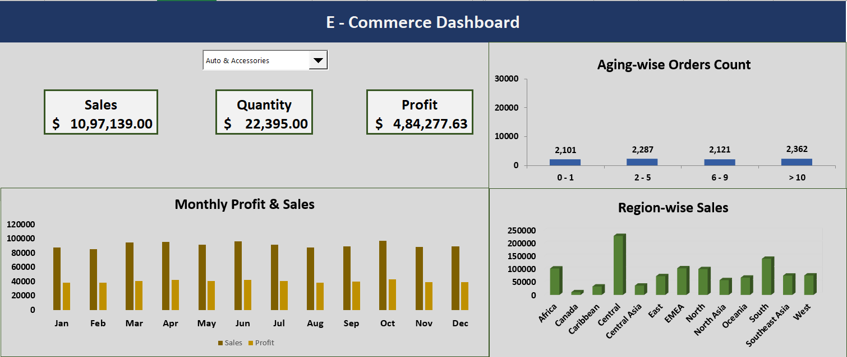The e-commerce dashboard created:

* 1. **Insights**
* Electronics is the least-selling category and is preferred by age group 0-1 only.
* The Central region generates the maximum sales for the company.
* In categories other than the Electronics, the distribution of orders is almost similar for all the age groups.

Affordable & Competent Courses | iNeuron.ai

* The sales and profit trends for each category keeps on changing monthly.

1. **Unit Test Cases**

|  |  |
| --- | --- |
| **TEST CASE DESCRIPTION** | **EXPECTED RESULTS** |
| Combo Box | When the combo box is clicked, it will show different product categories. |
| Different Metrics | Sales, Profit and Quantity- these will change upon choosing different categories. |
| Monthly Profit and Sales Chart | This column chart depicts the month-wise trends of the Sales and Profit |
| Aging-wise Orders Count | This column chart depicts the distribution of the count of orders in different age groups |
| Region-wise Sales | This column chart depicts the sales in different regions |